***The Friends of St James, Biddenham***

Bedford School Brass Ensemble

Conductor: Andrew Groom

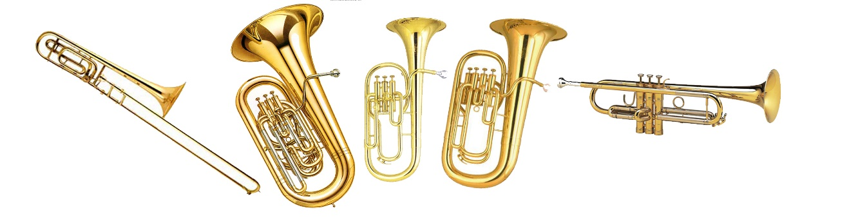

**Saturday 2nd March 2019, 7:30pm**

**St James’s Church, Biddenham**

Church End, Biddenham MK40 4AR

A concert of varied music to suit all tastes

*Drinks and snacks in the interval*

**Admission:**

£10 each (£8 for members of The Friends of St James)

*Children under 16* ***free***

**To book, please contact:**

Chris Haydn Jones (211759) or Diana Shooter (213305)

***In aid of The Friends of St James***

***- the charity which preserves and enhances the church, churchyard and barn for future generations***